
Second Edition
PHOTO: PRABIR DAS

DHAKA TUESDAY NOVEMBER 19, 2024

Regd. No. DA 781 Vol. XXXIV No. 298 Agrahayan 4, 1431 BS 13_Office-34_Akash Adhikary Pages Plus Life Style : Tk 15.00

100DAYSOFGOVT
Major steps taken
towards a ‘new
Bangladesh’

Inflation, law and order still remain worrisome, TIB observes in its report

STAFFCORRESPONDENT

Despite numerous challenges, the interim government over the last 100 days has taken many timely and significant steps that align with the vision of building a “new Bangladesh”, observed Transparency International Bangladesh yesterday.

It said the government move to try killers and human rights violators from the previous regime; efforts to provide compensation and medical care to those injured in the movement; and the repeal of the Cyber Security Act were noteworthy.

However, the expected reigning in of inflation has not happened and problems with law and order remain, it said.


KEY OBSERVATIONS

 Trial process for killers, human rights violators initiated

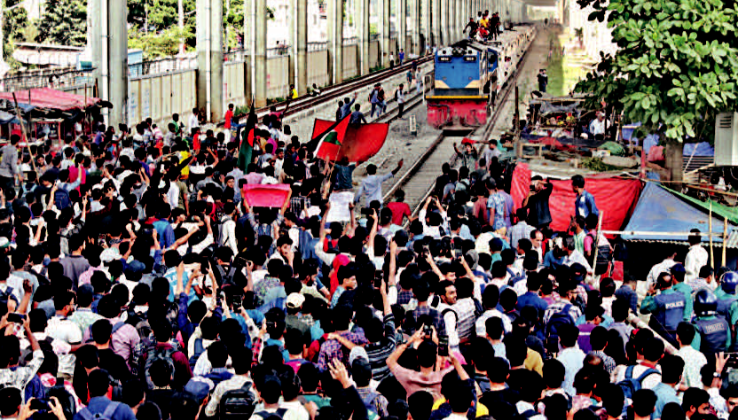

Students of Government Titumir College signal a train to stop during a demonstration at the capital’s Mohakhali level crossing yesterday. They were demanding the college be transformed into a university. The protest cut off Kamalapur Railway Station from the rest of the country for about four hours.

People to decide if polls first or reforms

Prof Yunus tells Al Jazeera


STARREPORT

Chief Adviser Prof Muhammad Yunus, in an interview with Al Jazeera, said his interim government is focusing on reforms of state institutions, but would announce elections anytime if people want it,

Measures taken to increase remittance, improve environment

No reforms commission made for banking sector

Concern remains over steps to prevent graft, money laundering

A lack of initiatives to reform political parties

Press freedom, the right to information under threat

Challenges also persist in bringing lasting reforms to key institutions, including the Election Commission, Anti-Corruption Commission, Human Rights Commission, and Information Commission, said the TIB.

It came up with the observations while unveiling a research report titled “New Bangladesh: Observations on the First 100 Days after the Fall of the Authoritarian Regime” at a press conference at its office in the capital.

The TIB presented its observations on 41 sectors, covering a wide range of issues, including political, administrative and institutional reforms, and appointments and reshuffles.

It also reviewed rule of law and human rights situations, the justice

SEE PAGE 2 COL 1
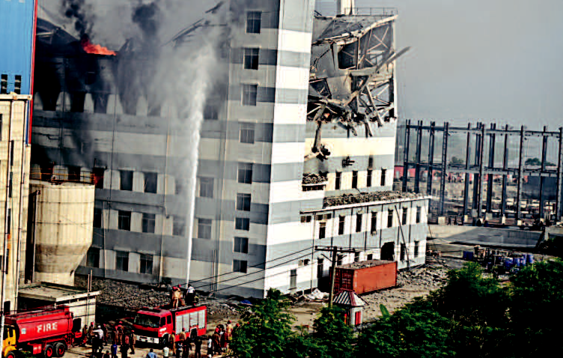

People suffer as students block road, rail line

Protesters hurl stones at train, injuring 15-20

STAFFCORRESPONDENT

The day-long blockade of roads and railways by students of Government Titumir College in the capital’s Mohakhali area, demanding the college be upgraded to a university, caused immense suffering to city residents yesterday.
Around 2,000 students took

SEE PAGE 2 COL 1

13 big shots
produced at ICT

Complete probe against Hasina, others in a month, tribunal asks prosecution
STAFFCORRESPONDENT |  | It asked the prosecution to complete
The International Crimes | Tribunal | the probe against former prime minister
The International Crimes | Tribunal | Sheikh Hasina and others in two genocide
(ICT), which has the special | mandate | cases by December 17. The arrestees are
to adjudicate crimes against humanity, |  | to be kept in detention until then.
experienced its first big day yesterday with |  | The tribunal also ordered the
13 high-profile members of the ousted |  | The tribunal also ordered the
 |  | prosecution to submit a report on the
government, including nine | former | execution of Hasina’s arrest warrant
ministers, being produced before it. |  | SEE PAGE 2 COL 4


with or without reforms. Asked about when the

election can take place, he said he has no definite answer to that.

SEE PAGE 2 COL 4


Firefighters tackle a blaze at a tissue factory owned by Meghna Group in Jhauchar area of Narayanganj’s Sonargaon upazila yesterday. Fire service officials said the building tilted and two floors collapsed due to intense heat.
PHOTO: COLLECTED
Moody’s goes negative

On bangladesh

Downgrades credit rating to ‘highly speculative’ B2


RISKS FLAGGED BY MOODY’S

 Lower economic growth

More govt liquidity risks

External vulnerabilities

Banking sector risks

Energy payments to strain reserve buffers

 Absence of polls roadmap to raise political risks

STAFFCORRESPONDENT

Major credit rating agency Moody’s yesterday downgraded its outlook on the Bangladesh economy to negative from stable owing to increased risks of political uncertainty, further deterioration in law and order and weak domestic demand.

It cut Bangladesh’s ratings from B1 to B2, incorporating heightened political risks and lower growth forecasts. A B2 rating means “highly speculative” and it comes with high

credit risks.

The heightened political risks come from the absence of a clear election roadmap, the deterioration of law and order and the nascent reemergence of community-based tensions, the American credit rating agency said in a report.

While economic activity has largely normalised under the interim government, political uncertainty punctuated by occasional lapses in law and order has weakened

domestic demand and weighed on activities in the garment sector, a key driver of the economy.

Moody’s also lowered Bangladesh’s growth projections for this fiscal year: the economy would grow by 4.5 percent, down from its earlier projection of 6.3 percent.

The negative outlook reflects downside risks to Bangladesh’s growth outlook beyond its current expectations, which could further

SEE PAGE 6 CO

Akash Adhikary
Roll-13
Batch-34

